Miles Shinsato

Nardos Gebremedhin

Jessica Long-Heinicke

Joseph Ayo

Adrian Marquez

12/7/24

CSD 310 – Group 1

Case Study: Bacchus Winery

**Deliverable #1 – Business Rules**

**1. Supply Chain Management**

* 1. **Supplier Monitoring**
* All suppliers must provide detailed delivery schedules and update them in real-time if there are changes
* Delivery performance must be reviewed monthly, with no more than 5% variance allowed between expected and actual delivery dates
  1. **Inventory Levels**
* Critical Inventory (bottles, corks, labels, etc.) must be maintained at a minimum of 30 days’ supply, based on average monthly usage
* Low inventory alerts must automatically trigger purchase orders to approved suppliers for restocking
  1. **Supplier Agreements**
* Supplier agreements must include penalties for late deliveries (beyond a 3-day grace period)
* All suppliers must be onboarded into an online procurement system for real-time order placement, shipping tracking, and communication

**Assumptions**

* Current suppliers are willing to adopt digital processes for tracking and order management
* Inventory restocking frequency will remain monthly unless production increases

**2. Distribution and Sales**

**2.1 Distributor Ordering**

* All distributors must use an online portal to place orders, eliminating manual order processes
* Orders must include tracking details (e.g., estimated delivery date, shipment stages) must be visible to both distributors and winery staff in real-time

**2.2 Sales Analysis**

* Sales data must be reviewed monthly to identify underperforming wines (e.g., those selling less than 50% of their expected sales targets) or high demand products (e.g., those selling out with retailers)
* Discounts and targeted marketing campaigns must be implemented for wines that are underperforming

**2.3 Wine Allocation**

* Each distributor must be assigned a sales quota per wine type with adjustments made quarterly based on past sales performance and trends

**Assumptions**

* All distributors have access to internet enabled devices for online order placement and tracking
* Existing marketing strategies can be adapted to focus on underperforming wines

**3. Employee Management**

**3.1 Time Tracking**

* All employees must clock in and out through a digital time tracking system ensuring accurate labor hour records
* Any employee working more than 40 hours per week must be flagged for overtime review

**3.2 Quarterly Employee Reports**

* Quarterly reports on employee hours worked must be generated and shared with department heads for workforce review and planning

**3.3 Performance Reviews**

* Employee productivity must be evaluated quarterly using tracked hours and output metrics as benchmarks
* Employees with performance issues must participate in performance improvement programs
  1. **Employee Management**
* Employees are to be grouped into departments (Finance, Marketing, Production, Supply Chain
* Departments are to be managed by one employee. No employee can manage more than one department

**Assumptions**

* Employees will adapt to the new time tracking system with minimal training
* Current labor laws regarding overtime and working hours are adhered to

**4. Reporting and Decision Making**

**4.1 Supplier Reports**

* Monthly supplier performance reports must highlight delivery times, delays and order accuracy

**4.2 Sales Reports**

* Monthly wine sales reports must include data by product and distributor, along with historical trends and performance metrics

**4.3 Employee Reports**

* Quarterly reports must include detailed breakdowns of hours worked per employee, department productivity, and overtime incurred

**Assumptions**

* Stan and Davis will review reports monthly and make decisions based on insights provided by these reports

**5. Technology Implementation**

**5.1 System Integration**

* All new systems (inventory management, online ordering, time tracking) must integrate into a central dashboard accessible to management

**5.2 System Training**

* All employees and distributors must undergo training sessions for all new systems to ensure proper adoption and usage

**5.3 Data Security**

* All digital systems must comply with standard data security standards to protect sensitive information (e.g., customer, supplier, and employee data)

**Assumptions**

* The winery has the budget and technical capability to implement and maintain these systems
* Employees and distributors will embrace the use of new technology after training

**6. Inventory and Supplier Management**

**6.1 Real-Time Shipment Updates**

* Suppliers must provide real-time shipment tracking and notify the winery of any delays exceeding 24 hours

**6.2 Seasonal Restocking Adjustments**

* Restocking thresholds must account for seasonal demand surges, with a 50% increase in buffer stock during peak periods (e.g., holidays or wine festivals)

**6.3 Quality Assurance**

* All deliveries must be inspected within 48 hours. Defective or non-compliant items must be reported immediately, with replacements arranged within 7 days

**6.4 Automated Reordering**

* Inventory levels must trigger automated purchase orders when stock falls below 30 days’ supply, based on average monthly usage

**6.5 Supplier Accountability Agreements**

* All supplier agreements must include clear accountability measures such as penalties for delays beyond the 3-day grace period and incentives for consistent, on-time performance

**Assumptions**

* Suppliers are willing and able to adopt digital systems for real-time tracking and communication
* Seasonal demand patterns are predictable based on historical data
* The winery has resources for automated systems and quality assurance processes
* Current storage facilities can handle increased buffer stock during high-demand periods

**Deliverable #2 - Entity Relationship Diagram**

**Visualization:**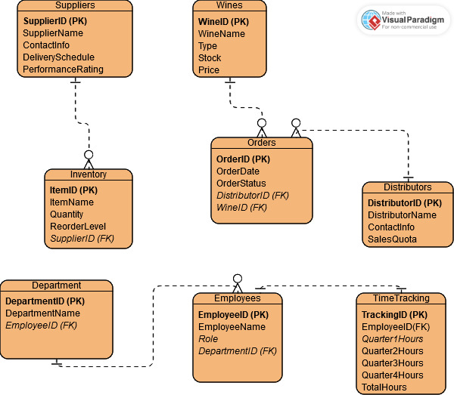

**Text Breakdown:**

* **Suppliers**
  + SupplierId (Primary Key)
  + SupplierName
  + ContactInfo
  + DeliverySchedule
  + PerformanceRating
* **Inventory**
  + InventoryId (Primary Key)
  + ItemName (e.g., bottles, corks)
  + Quantity
  + ReorderLevel (Minimum quantity triggering restock)
  + SupplierId (Foreign Key to Supplier)
* **Distributors**
  + DSistributorId (Primary Key)
  + DistributorName
  + ContactInfo
  + SalesQuota
* **Wines**
  + WineId (Primary Key)
  + WineName
  + WineType (e.g., red, white)
  + WineStock
  + Price
* **Departments**
  + DepartmentId (Primary Key)
  + DepartmentName
  + EmployeeId (Foreign Key)
* **Employees**
  + EmployeeId (Primary Key)
  + EmployeeName
  + Role (e.g., Finance, Marketing, Production)
  + DepartmentId (Foreign Key)
* **TimeTracking**
  + TrackingId (Primary Key)
  + EmployeeId (Foreign Key)
  + Quarter1Hours
  + Quarter2Hours
  + Quarter3Hours
  + Quarter4Hours
  + TotalHours

**Relationship Breakdowns:**

Suppliers to Inventory

One to Many – Each supplier can provide multiple inventory items

Wines to Orders

One to Many – Each wine can appear to multiple orders

Distributors to Orders

One to Many – Each distributor can purchase multiple orders

Employees to Departments

Many to One – Each department can have multiple employees

Employees to TimeTracking

One to One – Each employee can have only one time tracking record that aggregates all quarterly hours during specific time periods